
Register Number

SRM INSTITUTE OF SCIENCE AND TECHNOLOGY
Set - A
SRM Nagar, Kattankulathur – 603203, Chengalpattu District, Tamil Nadu
College of Engineering and Technology
School of Computing
Department of Data Science and Business Systems
Academic Year: 2023-24 (Odd)

Test | : CLA-T1 | Date | : 11-08-2023
Course Code & Title | : 18CSE487T – Data warehousing and Its  Applications | Duration | : 50 Minutes (1 Period)
Year & Sem | : III&IV Year /V& VII Sem | Max Marks | : 25

Course Articulation Matrix:
S.No. | Course Outcome | PO1 | PO2 | PO3 | PO4 | PO5 | PO6 | PO7 | PO8 | PO9 | PO10 | PO11 | PO12 | PO13 | PO14 | PO15
1 | CO1 | 3 | - | - | - | - | - | - | - | - | - | - | - | - | - | -
2 | CO2 | 3 | - | - | - | - | - | - | - | - | - | - | - | - | - | -
3 | CO3 | 3 | - | - | - | - | - | - | - | - | - | - | - | - | - | -
4 | CO4 | 3 | - | - | - | - | - | - | - | - | - | - | - | - | - | -
5 | CO5 | 3 | - | - | 3 | - | - | - | - | - | - | - | - | - | - | -
6 | CO6 | 3 | - | - | - | - | - | - | - | - | - | - | - | - | - | -

Part – A
(5 x 1 = 5 Marks)
Instructions: Answer all
Q. No | Question | Marks | BL | CO | PO | PI Code
1 | What is the name of the source of all data warehouse data?  a. Formal environment  b. Data warehouse environment  c. Operational environment  d. Technology environment | 1 | L1 | 1 | 1 | 1.3.1
2 | Determine the proper choice that specifies Datamart.  a. A subgroup of data warehouse  b. Another type of data warehouse  c. Not related to data warehouse  d. Datalake | 1 | L2 | 1 | 1 | 4.2.2
3 | Determine the operation that can be carried out in the data warehouse.  a. Alter  b. Modify  c. Scan  d. Read and Write | 1 | L2 | 1 | 1 | 4.2.2
4 | Data warehouse is based on  a. 1D Model  b. 2D Model  c. Network Model  d. Multidimensional Model | 1 | L2 | 1 | 1 | 1.3.1
5 | In a data warehouse, DSS stands for  a. Decision single system  b. Decision support system  c. Data support system  d. Data storable system | 1 | L1 | 1 | 1 | 1.3.1
Register Number

Set - A
Part – B
(2 x 10 = 20 Marks)
Instructions: Answer any Two Questions
6 | Explain Data warehouse with staging area and data marts with their various components | 10 | L3 | 1 | 1 | 1.3.1
7 | Explain in detail about dependent DataMart and hybrid DataMart. | 10 | L3 | 1 | 1 | 1.3.1
8 | Differentiate between Data mart and Data warehouse. | 10 | L2 | 1 | 4 | 4.2.2

Course Outcome (CO) and Bloom’s level (BL) Coverage in Questions

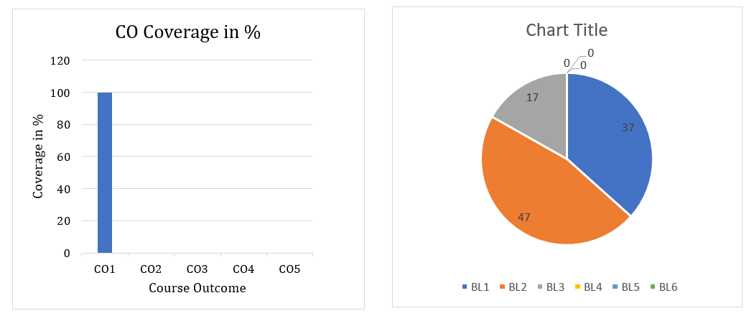

Approved by the Audit Professor/Course Coordinator

